May 6, 2018
From the Forest
Trash and Go Seek
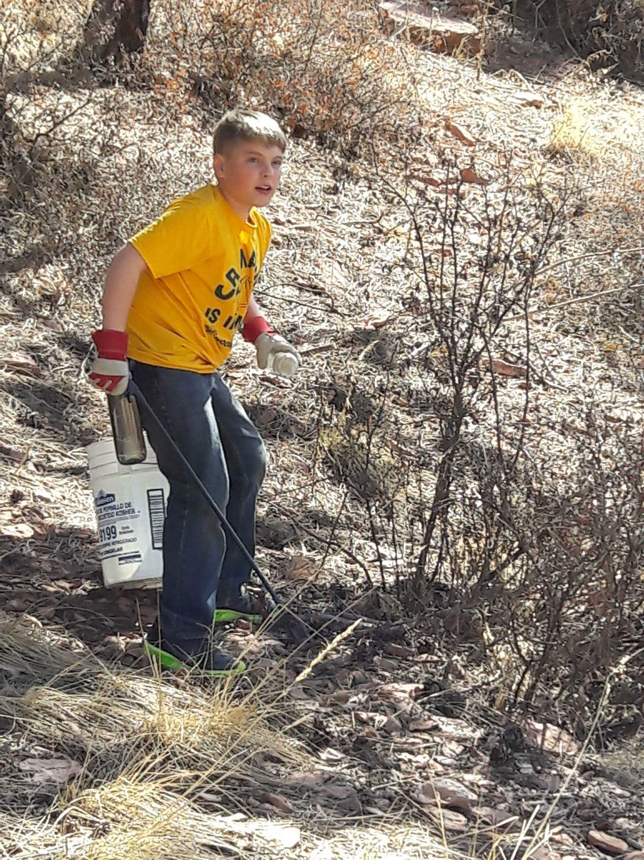
There are times that trash pick ups in national forest feel like a really big game of Hide-and-Go-Seek, only now instead of a backyard or school playground our hiders are spread over a few hundred square miles of topographically varied, densely forested wilderness. There are times the trash is like the kid in the bright red shirt that laid down in the middle of the green soccer field hoping you would not see him, right there along the side of the road begging to be picked up. Other times trash sites are like that kid that knows all the best spots and blends in so well that even when someone points her out you can’t see her.
On the last Sunday in April we finally found our troublesome hider on FS315. We had been given directions like FS315 section 13 follow the flags down the valley past the aspen grove. At least three times over the past eight weeks we had gone out looking and our elusive trash pile stayed hidden. Finally after almost walking by the site again we happened to look up in the right direction and there it was. The trash site was two hundred yards off the road tucked under the trees. It took five people two and a half hours and some creative ingenuity to get the approximately 70 cubic feet of trash including one heavy punching bag and some 7 pounds free weights out to the road and on their way to a proper disposal.
It is the comradery, sense of purpose and the challenge that hooks most of us and keeps us coming back again and again. We take pride in a job done well and that the next person in the area will see a clean forest. So, who is ready for our next round of Trash-and-Go-Seek?
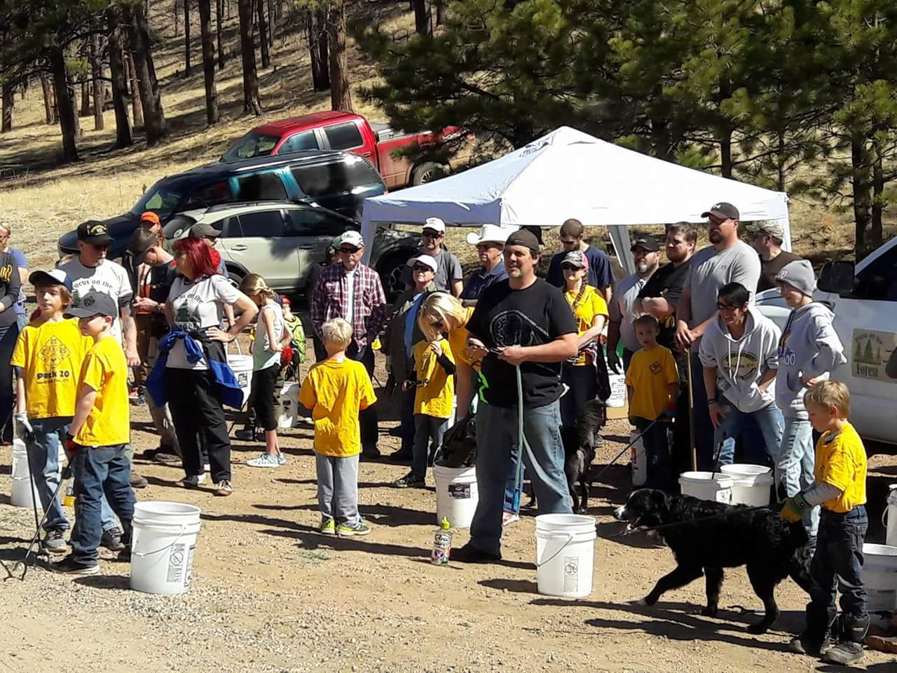
Trash Talk
What do you get when you combine sunshine, blue skies, warm temperatures and 92 motivated youth, families and friends? You get a highly successful Scout Day Clean Up! While not highest volume trash collection we have had, we were successfully able to remove several cubic yards of trash from the Rainbow Falls Off-Road Recreation Area north of Woodland Park. In conjunction with both boy scouts and girls scouts this was the largest group of young people Focus on the Forest has had participate in a single clean up event. The group was large enough we were able to expand beyond our initial target area and clean up other nearby valleys and campsites. Among all the trash some of the scouts even found a plastic slide from an outdoor playset that had been dumped.
Safety Blip
As the weather gets warmer our season picks up and we try to have more clean ups we have to keep in mind that we need to stay hydrated when out in the forest. At the elevations we work at it is easy to not be aware of how much we are sweating. The nature of our work also makes it easy to leave our water in the car because “it is just a little trash” and the next thing we know we are miles from the vehicle with several heavy trash bags and a splitting headache. Proper hydration is key to being able to keep working. It helps to prevent headaches and cramping while picking up trash. We encourage everyone to carry a refillable water bottle with them whenever they are out in the forest. At every cleanup we have jugs of water to refill water bottles and for anyone who forgot a water bottle we try to have bottles of water that people can refill.
Volunteer Spotlight
Tami Donaldson has been helping the Focus on the Forest board get all it documentation in order so we are in a position to pursue grants, approach businesses for larger donations and to be in a better position to work with the forest service. She also joined us for her first clean up on April 28th for Scout Day helping out with the information booth. Tami also brings a partnership with Veteran Support Solutions, an organization focused on getting homeless veterans and other homeless individuals the support and resources they need. This allows Focus on the Forest to direct any Forest Neighbors to an organization specifically formed to help them and maintain our focus on our mission. Thank you Tami for joining with Focus on the Forest.
Upcoming Events
Here is a brief list of upcoming events. Check out our website for event details and email us to get involved.
Tuesday, 5/15/2018 – Group Leads meeting in preparation for the Spring Focus on the Forest Day
Saturday, 5/19/2018 – Spring Focus on the Forest Day; Above the Clouds chapter at Rainbow Falls & Tri-Lakes chapter at Lower Gold Camp Road
7/5/2018 – Volunteer support for Symphony Above the Clouds
Focus on the Forest Needs You
We are looking for people interested in being Group Leads for our upcoming Focus on the Forest Day event.

